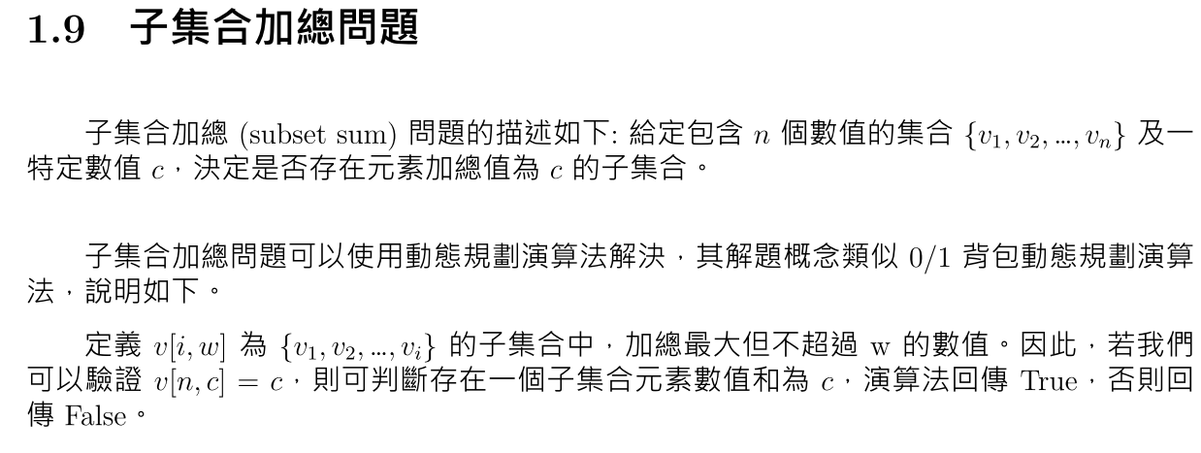

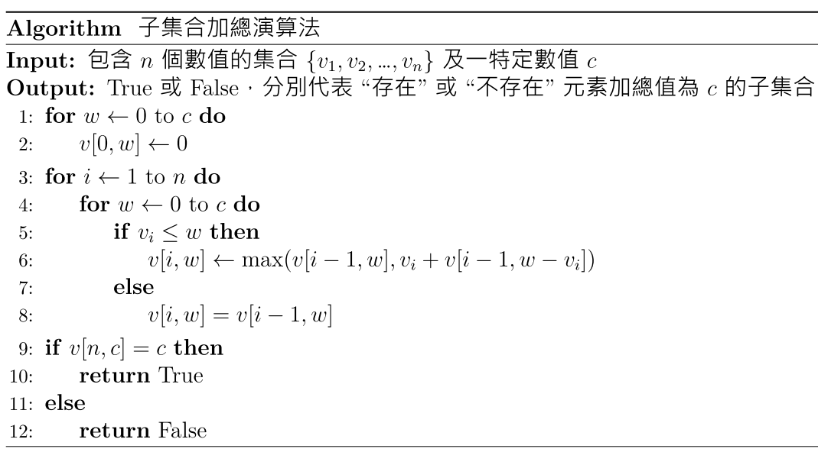

Sample input

3

3 7 10 5 2 6 17 56;33

14 28 72 69 39 5 11 3;238

323 452 371 498 167 84 595 999;2873

Sample output

True

True

False